AIN SHAMS UNIVERSITY  FACULTY OF ENGINEERING  International Credit Hour Engineering Programs (ICHEP)  Computer Engineering and Software Systems Program (CESS) | 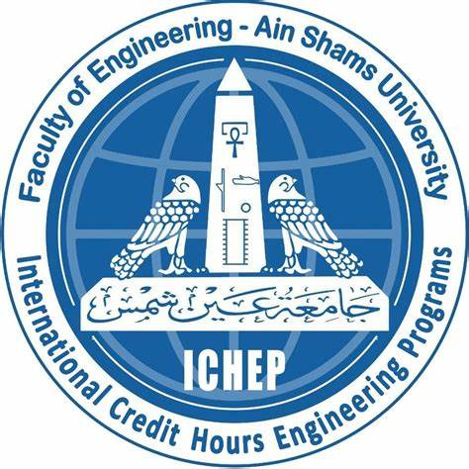
Web Development

Lab 6 Report

Name: Ahmed Hazem AbdulRahman Khalil Ibrahim
ID: 22P0226
Sec: 3

Group: 2
 | 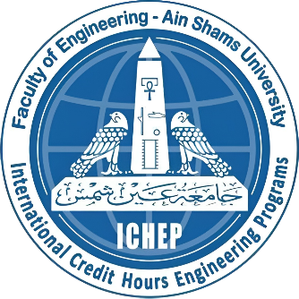

AIN SHAMS UNIVERSITY

FACULTY OF ENGINEERING

International Credit Hour Engineering Programs (ICHEP)
Computer Engineering and Software Systems Program (CESS)
Web Development
Done by: |  | Ahmed H. Khalil

Table of Contents
1.0 Exercise 1 Error! Bookmark not defined.
1.1 Screenshots Error! Bookmark not defined.
2.0 Exercise 2 Error! Bookmark not defined.
2.1 Screenshots Error! Bookmark not defined.
3.0 Exercise 3 Error! Bookmark not defined.
3.1 Screenshots Error! Bookmark not defined.

1.0 Screenshots

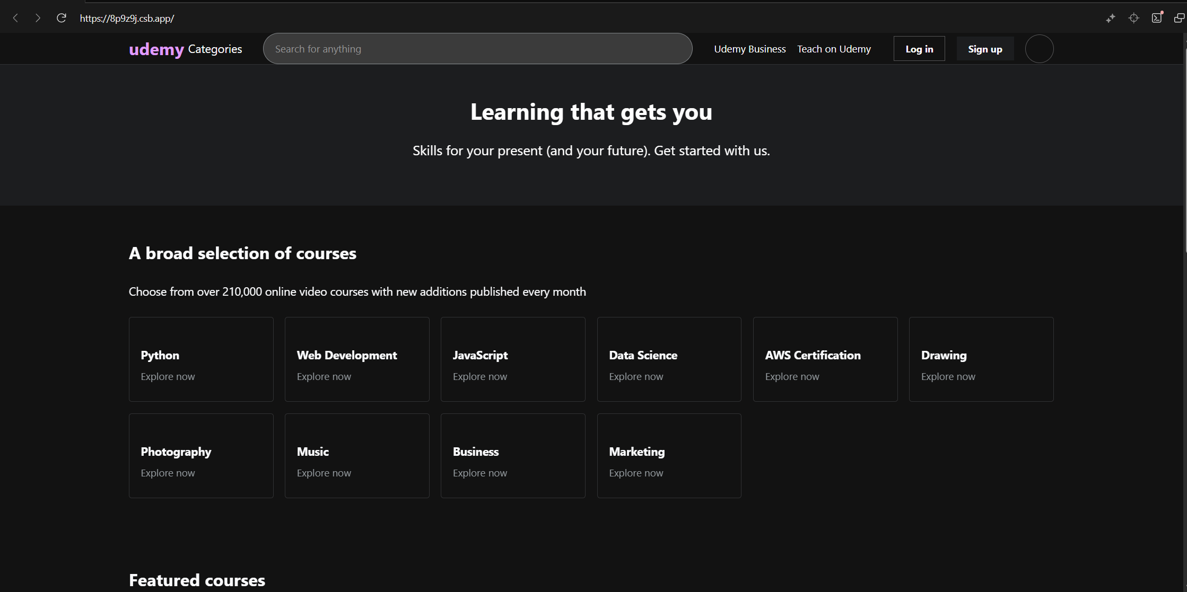

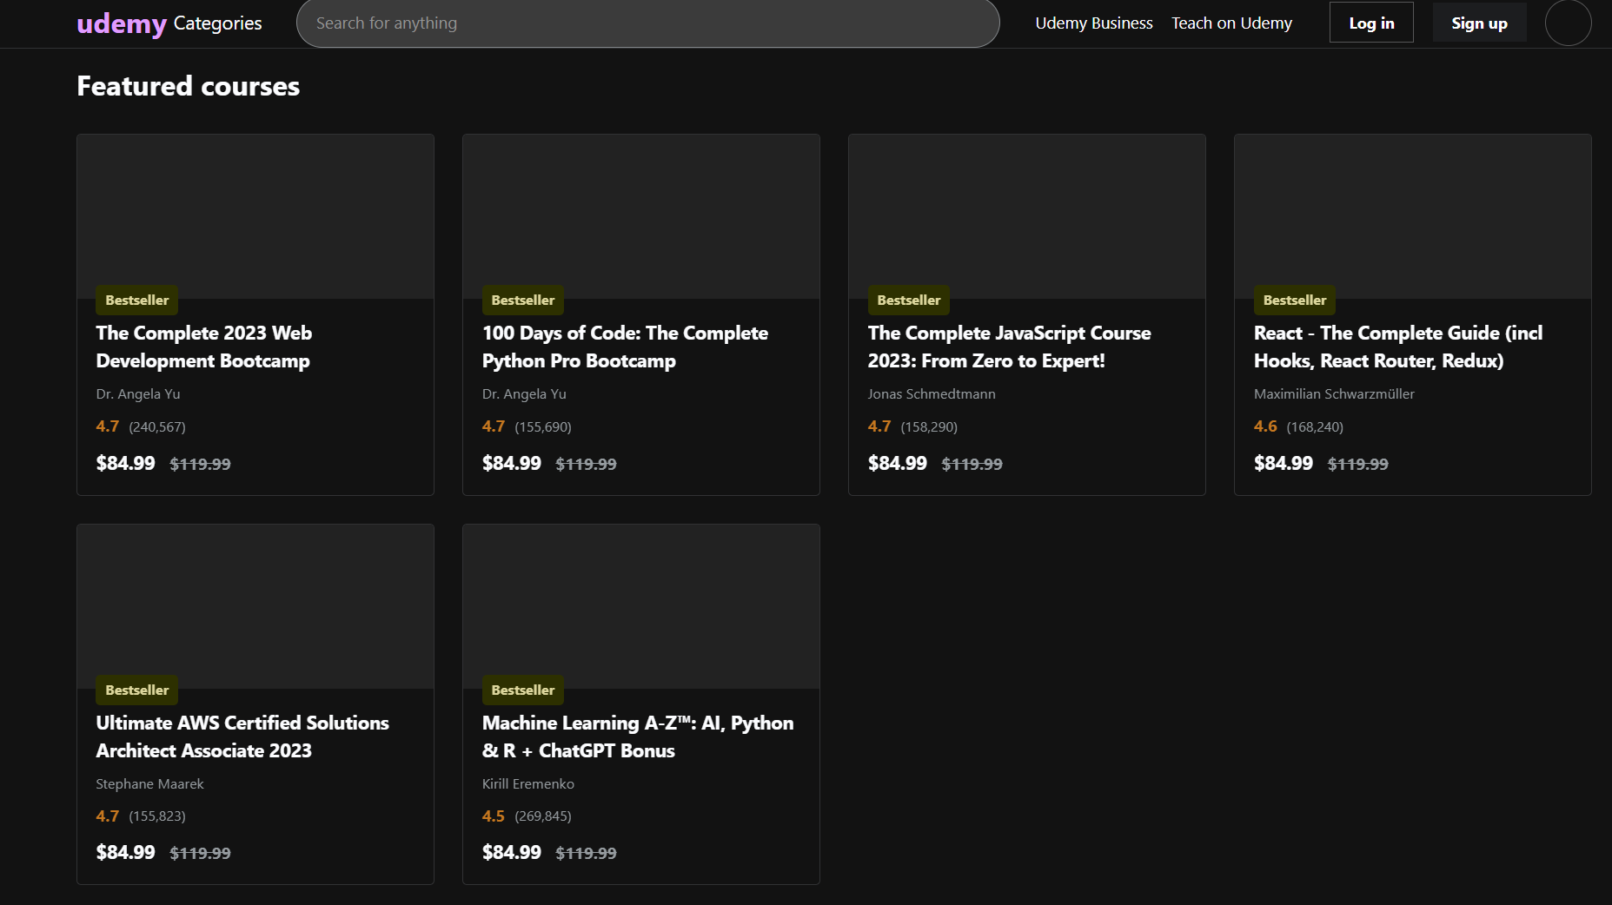
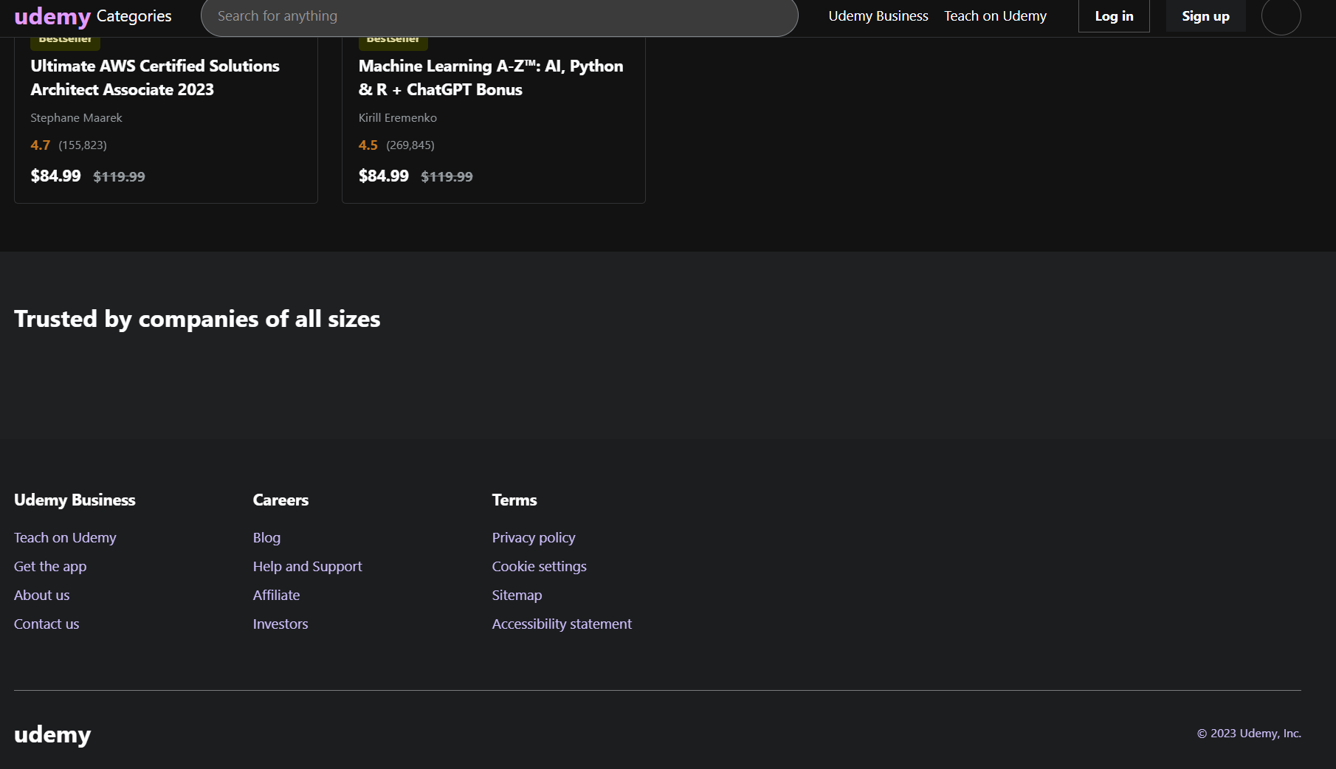

2.0 GitHub Link
AHZ404/WebDevLab6

